**COVID-19 Trend Analysis Report**

By Sandhya Viswanath

**Background:**

The report depicts the growth and spread of COVID-19 across the globe as part of my final Masters project during Spring 2020.

**Objective:**

Trend analysis of confirmed COVID-19 cases, recoveries and fatalities globally (and ability to drill down to US states) across time and by country.

**Data:**

Source: <https://github.com/CSSEGISandData/COVID-19/tree/master/csse_covid_19_data/csse_covid_19_time_series>

The data spans from Jan 2020 until Jan 14th 2021. The data for 191 country/regions is available in GitHub in multiple data files -

* + time_series_covid19_confirmed_global.csv
  + time_series_covid19_deaths_global.csv
  + time_series_covid19_recovered_global.csv
  + time_series_covid19_confirmed_US.csv
  + time_series_covid19_deaths_US.csv

**Data Cleanup and Pre-Processing:**

* Consolidate all data sets into one data frame.
* Imported datetime to work with dates as date objects
* Excluded cruise ships from our analysis. Also excluded West Bank and Gaza due to bad data
* Replaced null values with ‘NaN’ strings to make data more manageable
* Transposed all the date columns into rows using pd.melt functionality to restructure our dataset. This is useful when one or more columns are identifier variables and the rest have to be converted into rows.
* To track the number of new cases, created a new metric to capture the difference of cases today from a day before.

**Data Analysis & Visualizations:**

The project has an emphasis on explanatory analysis and visualizations. Analysis includes global confirmed cases and fatalities over time; trend of new cases globally (and by country); trend of confirmed cases by US states.

Numpy, Pandas library were used for the analysis and Plotly for visualization within Python. These visuals are interactive intuitive insights.

**Code:**

I have attached my ipython notebook which has all the code and visualizations. I have also attached a Google Colab link to view the code below.

Google Colab Link:

<https://colab.research.google.com/drive/1kCo7570dsJIcTSDpIUx0AZzoAI4XUQg_?usp=sharing>

I have created interactive dashboards in Tableau. I am attaching screenshots of my dashboard in case there are certain issues while opening the Tableau file.

This interactive dashboard gives an overview of the impact of COVID across the globe.

COVID-19 Statistics dashboard gives a one-click view of global trend (with drill down capabilities by country), US trends and New cases reported daily worldwide.

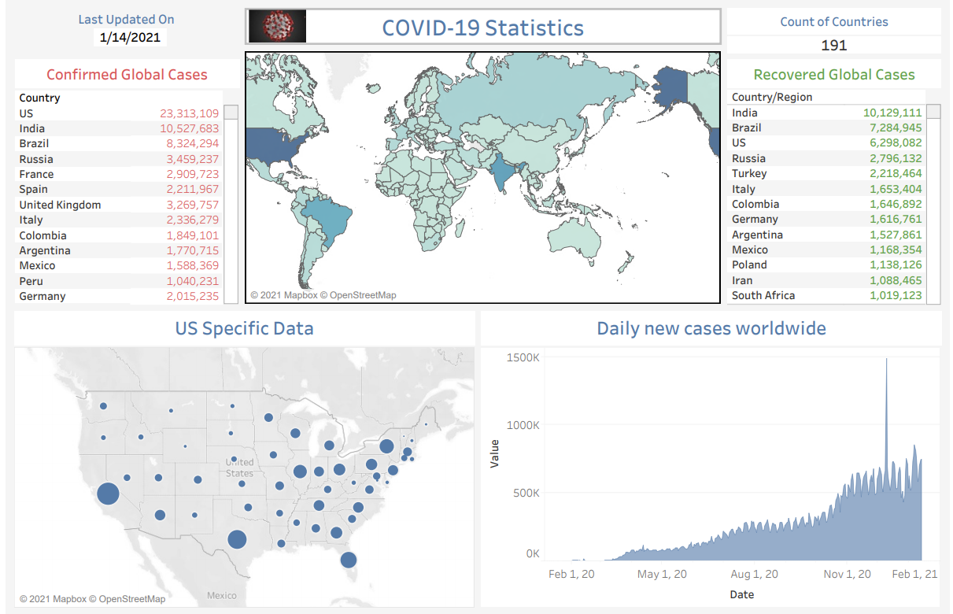

When you click on any country on the world map, you can see confirmed and recovered global cases data specific to the selected country

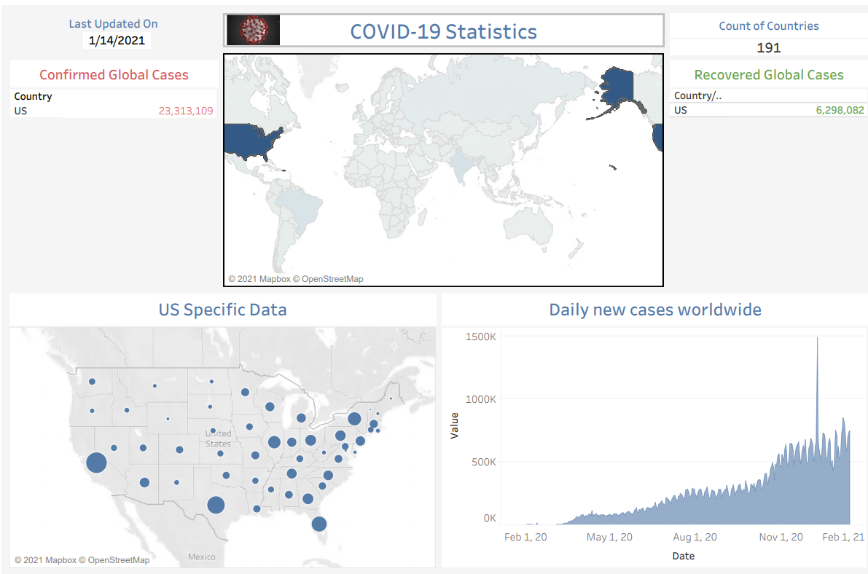

Hovering over US states gives you the confirmed, fatalities and mortality rate of that state using the tooltip option. This is helpful to gain quick knowledge of the numbers by hovering over the states.

